**PRACTICAL-3**

**AIM:**

**a.** Write a program to check whether the given string is palindrome or not.

**Source Code:**

def is_palindrome(input_str):

input_str = input_str.lower() # Convert to lowercase to make it case-insensitive

input_str = input_str.replace(" ", "") # Remove spaces

return input_str == input_str[::-1]

user_input = input("Enter a string: ")

if is_palindrome(user_input):

print(f"{user_input} is a palindrome.")

else:

print(f"{user_input} is not a palindrome.")

**Output:**

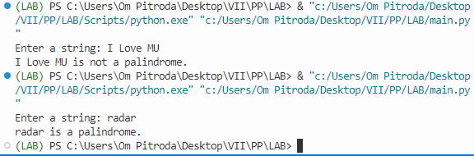

**b.** Write a program that accepts a string from user and performs the following operations:

i) Print the string in reverse order

ii) Print all the odd indexed characters of the string

iii) Print the count of all the vowels in the string

iv) Print the count of the frequency of an input character in the string

**Source Code:**

user_input = input("Enter a string: ")

reverse_string = user_input[::-1]

print(f"Reversed string: {reverse_string}")

odd_characters = user_input[1::2]

print(f"Odd indexed characters: {odd_characters}")

vowels = "aeiouAEIOU"

vowel_count = sum(1 for char in user_input if char in vowels)

print(f"Vowel count: {vowel_count}")

char_to_count = input("Enter a character to count: ")

char_count = user_input.count(char_to_count)

print(f"Frequency of '{char_to_count}' in the string: {char_count}")

**Output:**

